**CISC3029 Project : Hybrid Image**

WONG KAI YUAN DC026157

1. **Build Gaussian & Laplacian Pyramid**
2. Algorithm Flow Chart

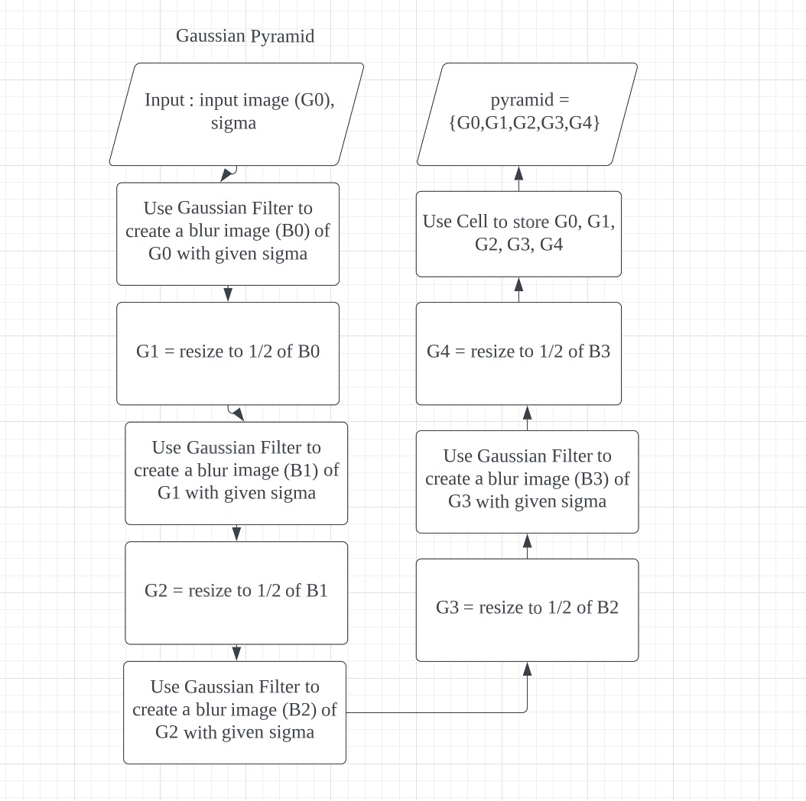

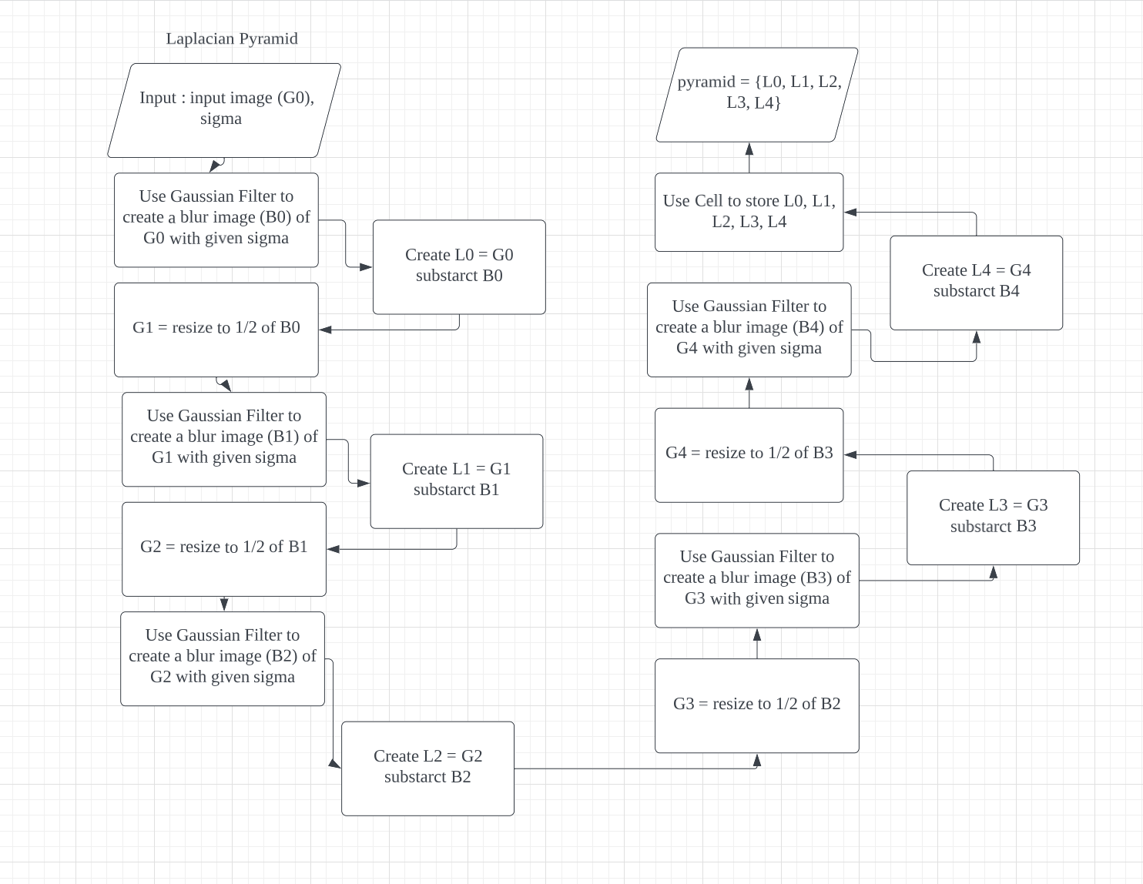

1. Code & Output results (Code is in another folder)

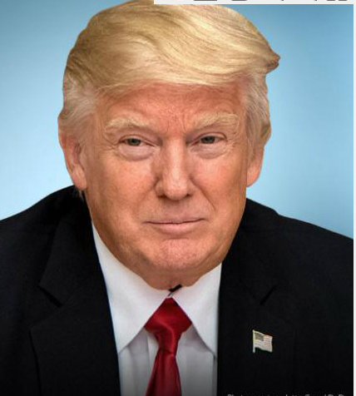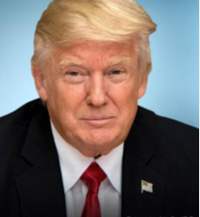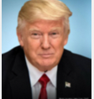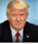

Gaussian Pyramid

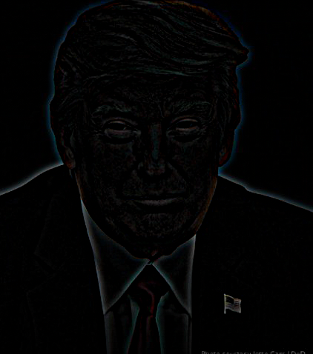 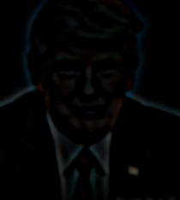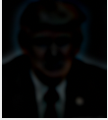 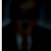

Laplacian Pyramid

1. **Hybrid Image**
2. Algorithm Flow Chart

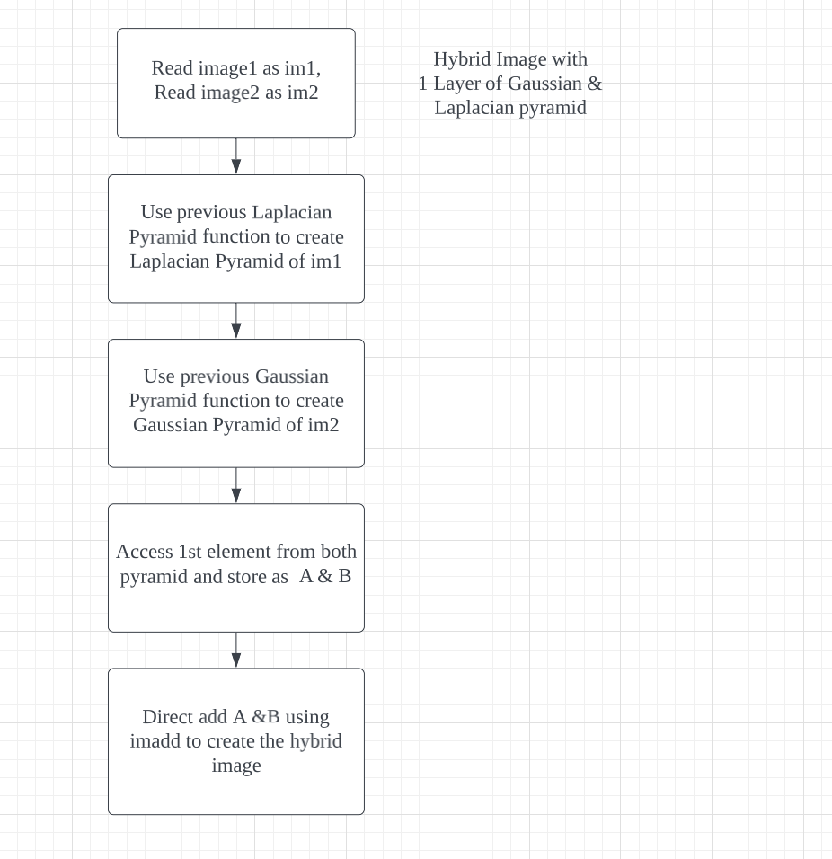

1. Code & Output results (Code is in another folder)
2. Cat & Dog

Laplacian: Cat (Able to see at near)

Gaussian: Dog (Able to see at far)

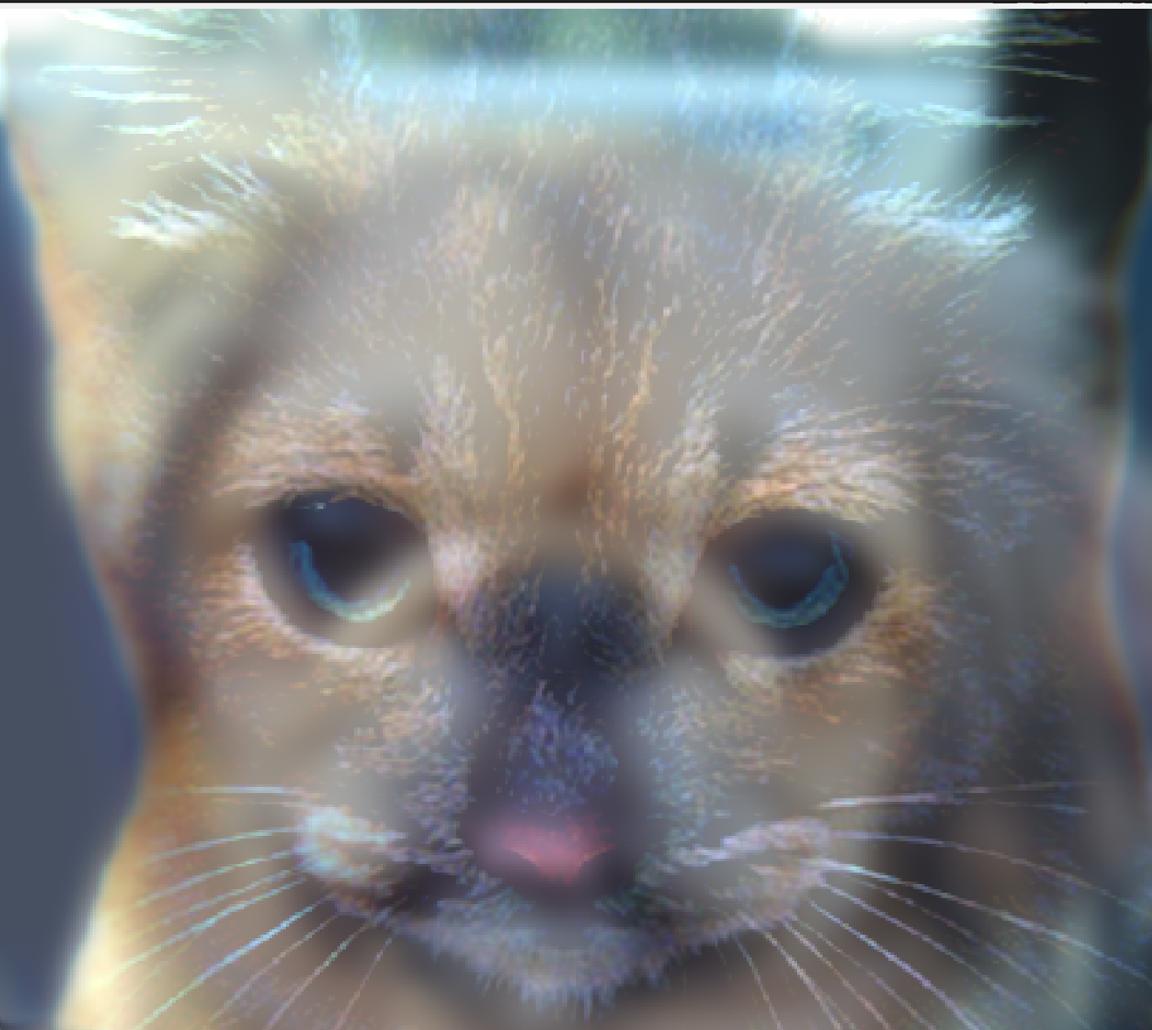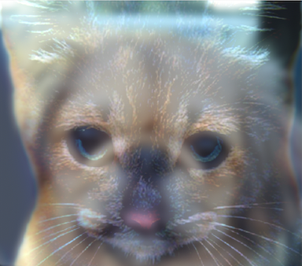

1. Far & Close

Laplacian: CLOSE (able to see at near)

Gaussian: FAR (able to see at far)

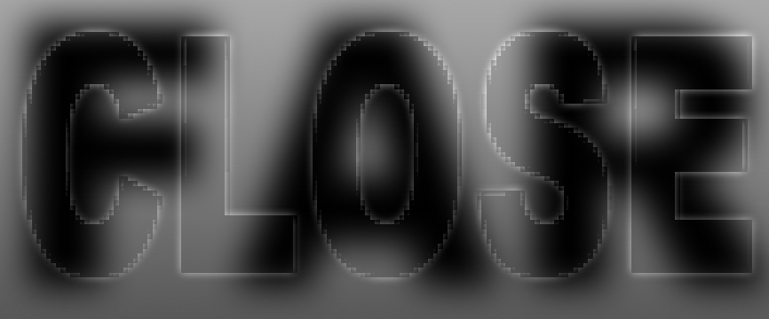



1. Trump & Putin

Laplacian : Donald Trump (able to see at near)

Gaussian : Putin (able to see at far)

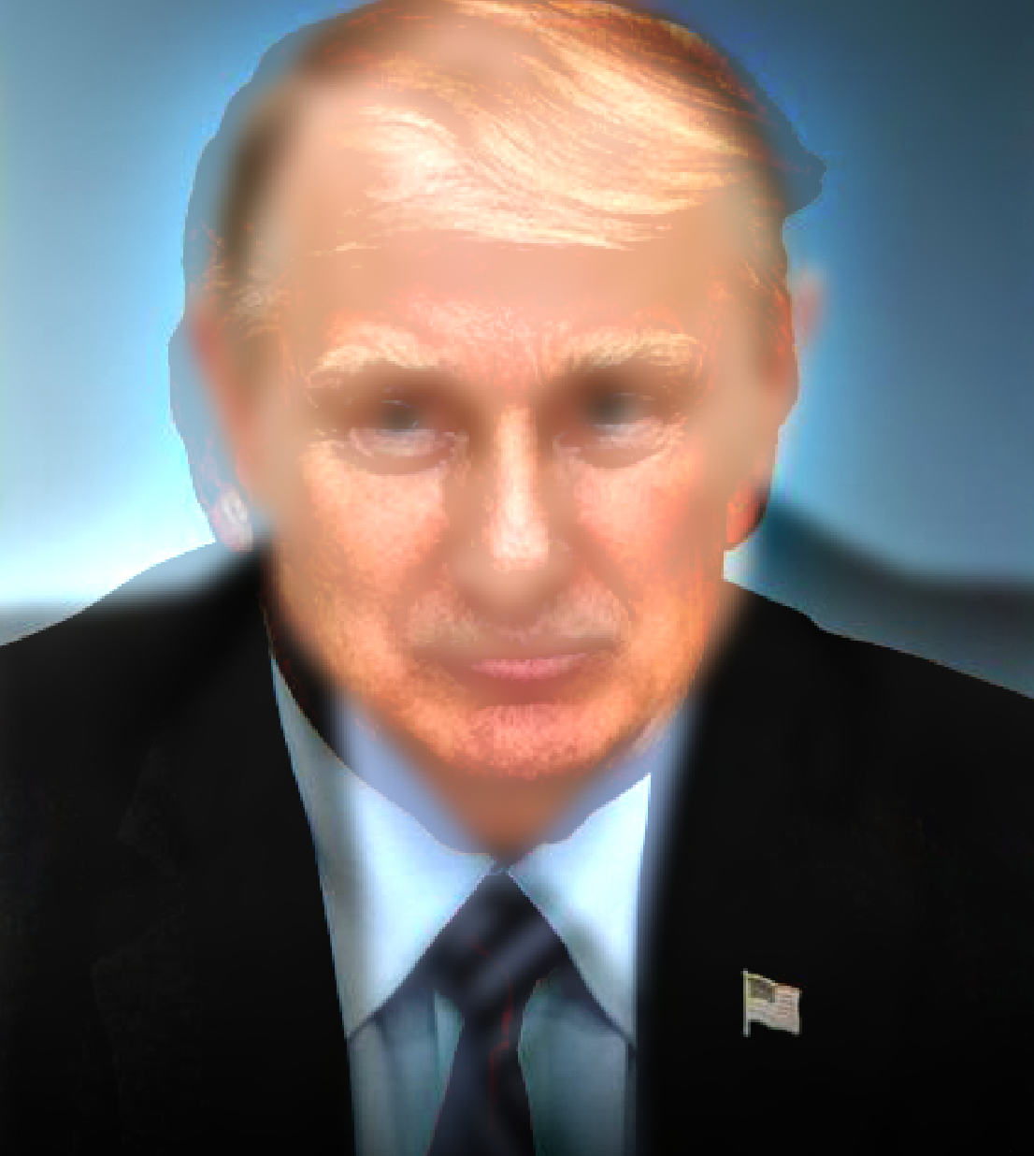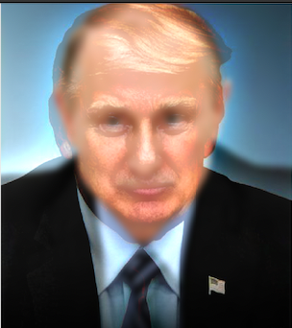

1. **Region Blending**
2. Algorithm Flow Chart

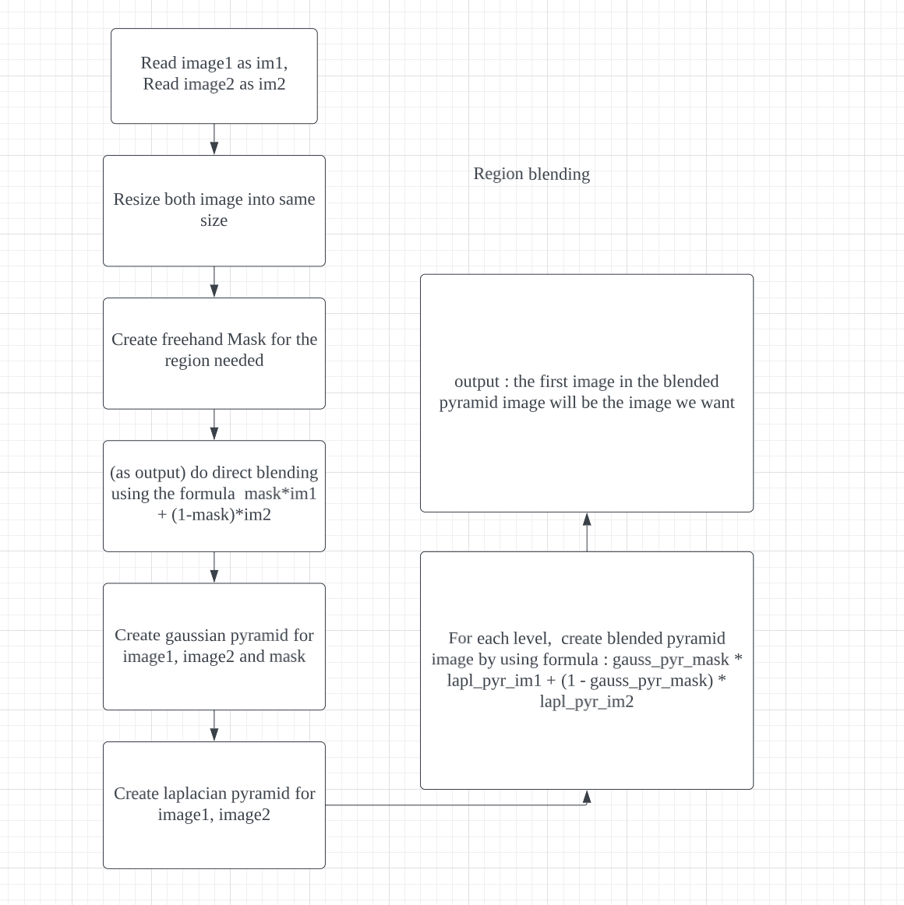

1. Code & Output Images (Code is in another folder)
2. Image1 : Background (New York Times Square)

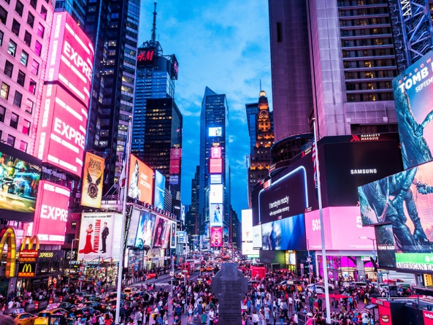

1. Image2 : Object (Elon Musk)

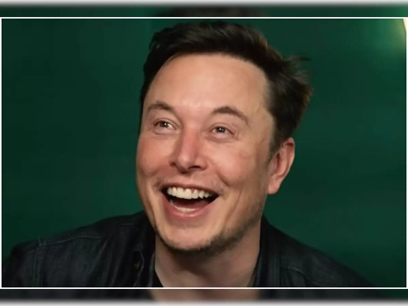

1. Image3 : Hand Drew to create Mask on object

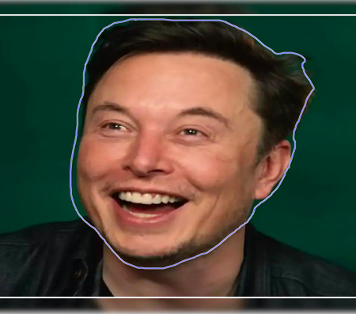

1. Image4 : Direct Blending

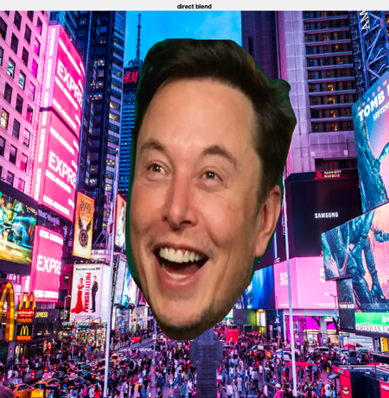

1. Image5 : Laplacian Blending (smooth blending)

